
ISTANBUL TECHNICAL
0
1
UNIVERSITY

COMPUTER ENGINEERING

DIGITAL CIRCUITS LABORATORY
EXPERIMENT REPORT

EXPERIMENT NO: 3

EXPERIMENT NAME: BINARY NUMBERS AND ARITHMETIC OPERATIONS

EXPERIMENT DATE : 15.03.2013

GROUP NO: 6

STUDENTS WHO DID THE EXPERIMENT:

Student no Name Surname

040100113 MUSTAFA UÇAR
040100117 TUĞRUL YATAĞAN
040100124 EMRE GÖKREM

ASSISTANT NAME WHO ASSISTED THE EXPERIMENT: CUMALİ TÜRKMENOĞLU

Aim:

Experiment #1
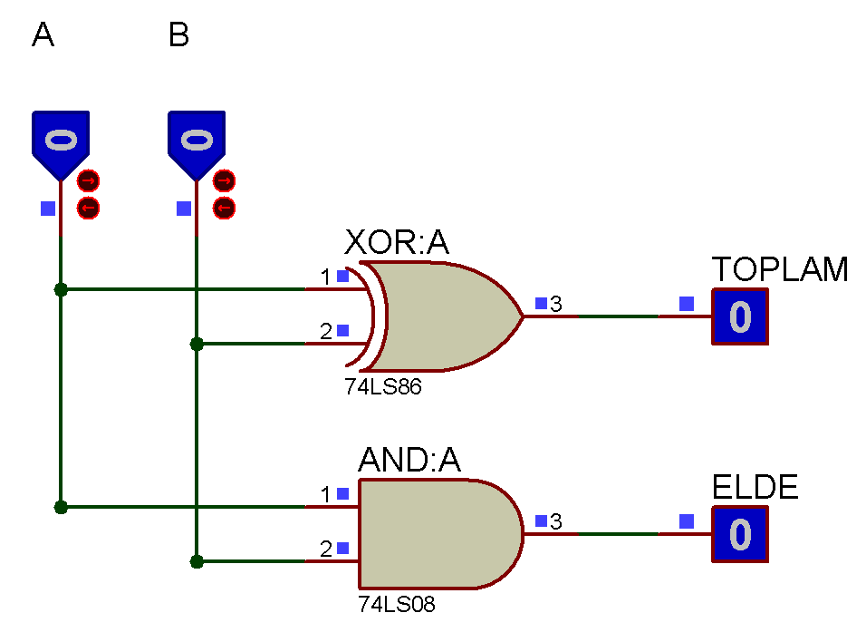
Experiment #2
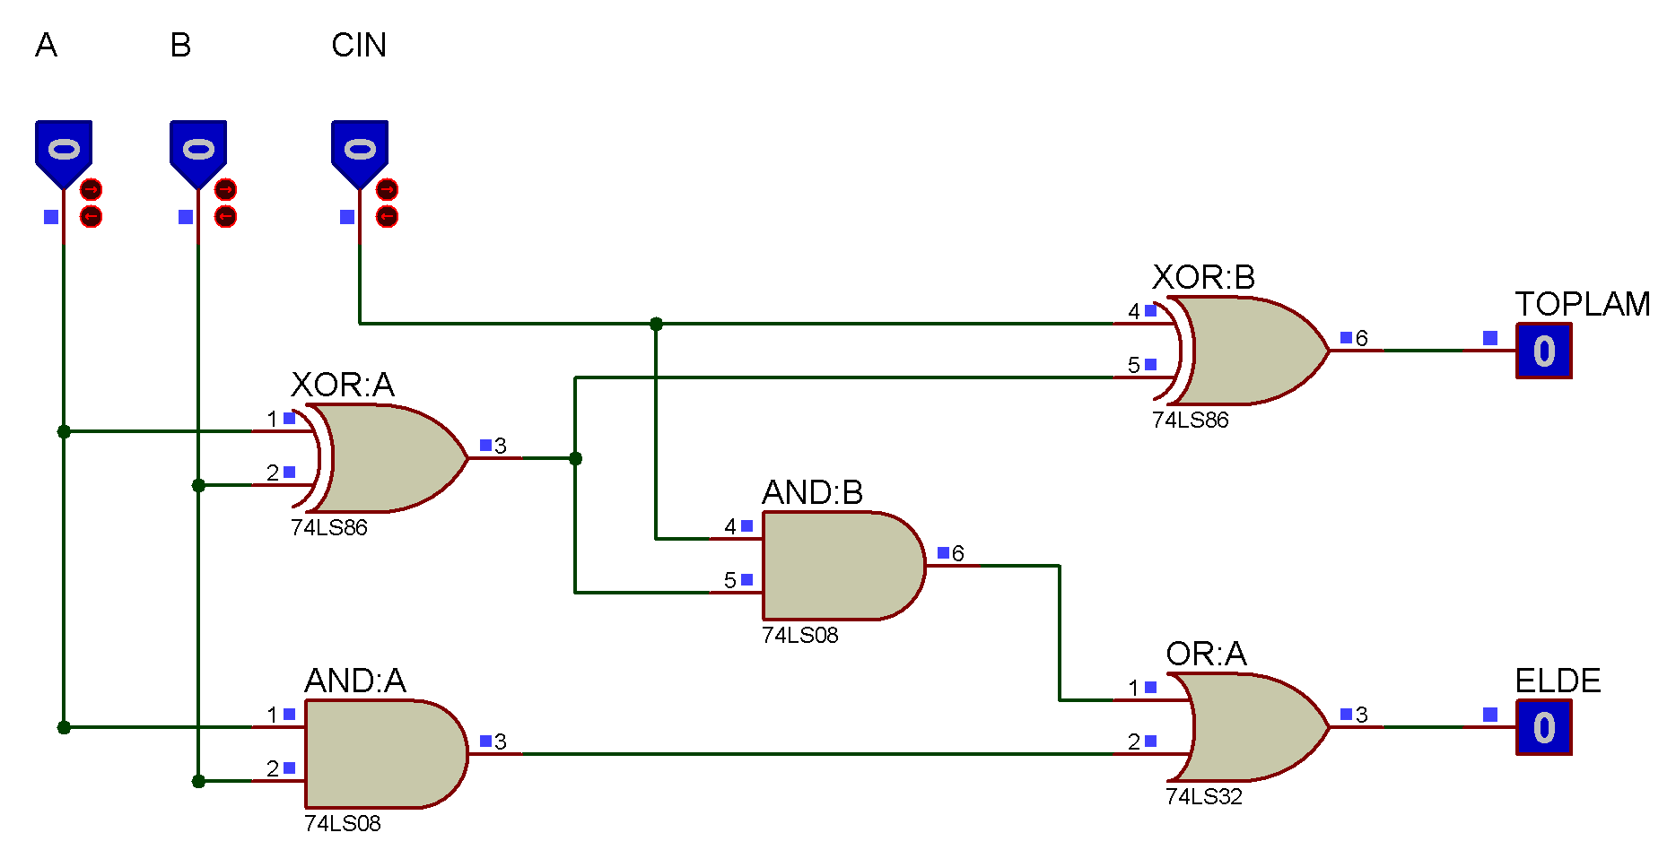
Experiment #3
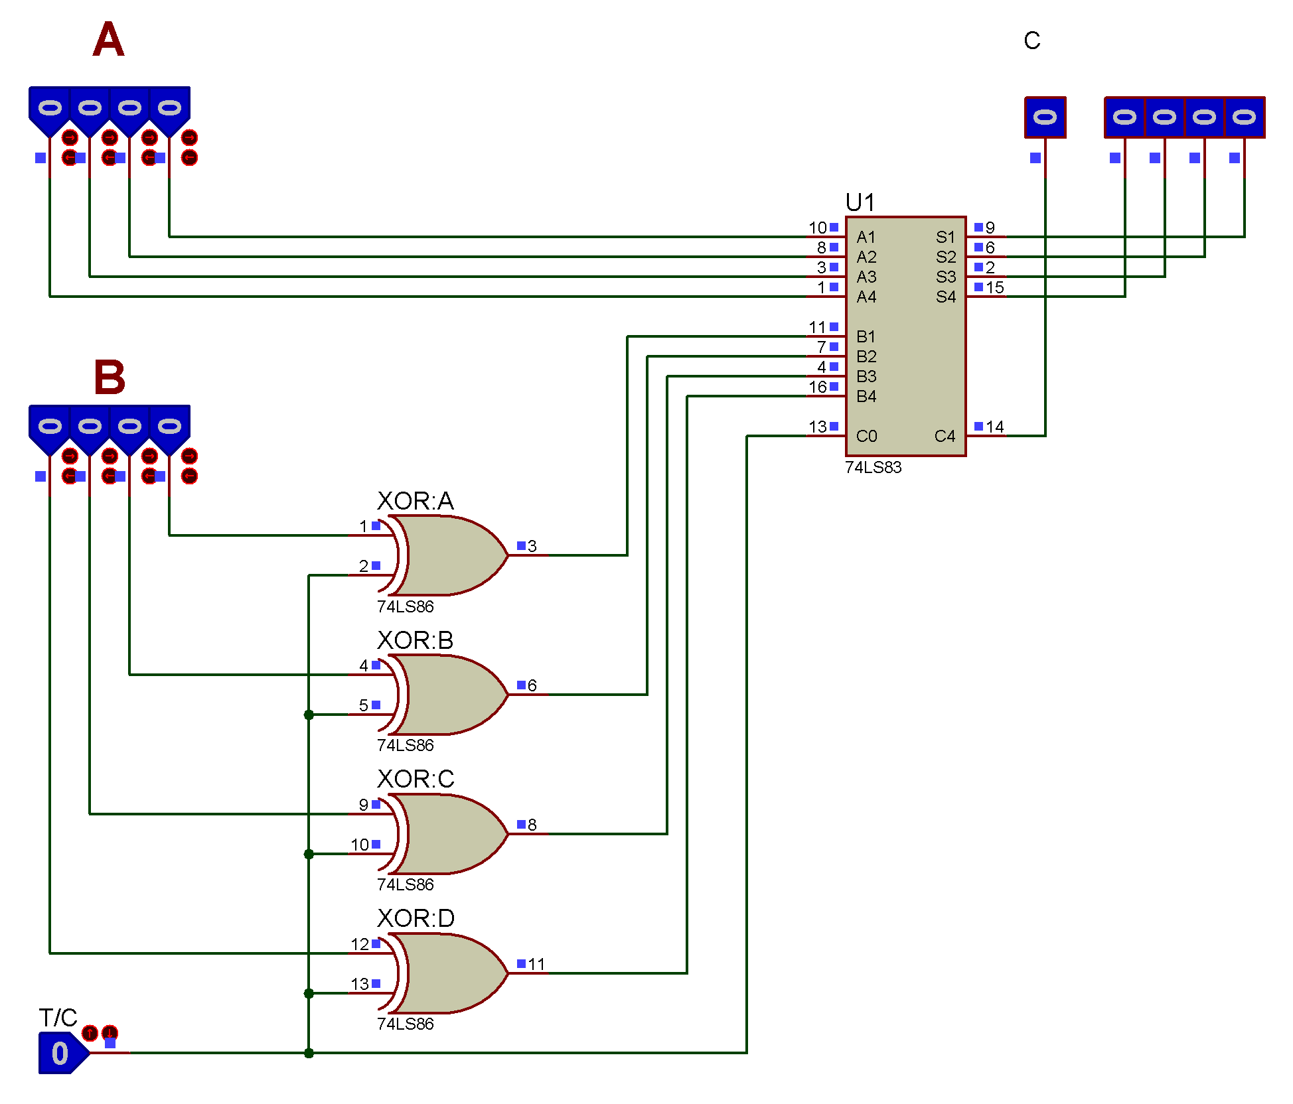
Experiment #4
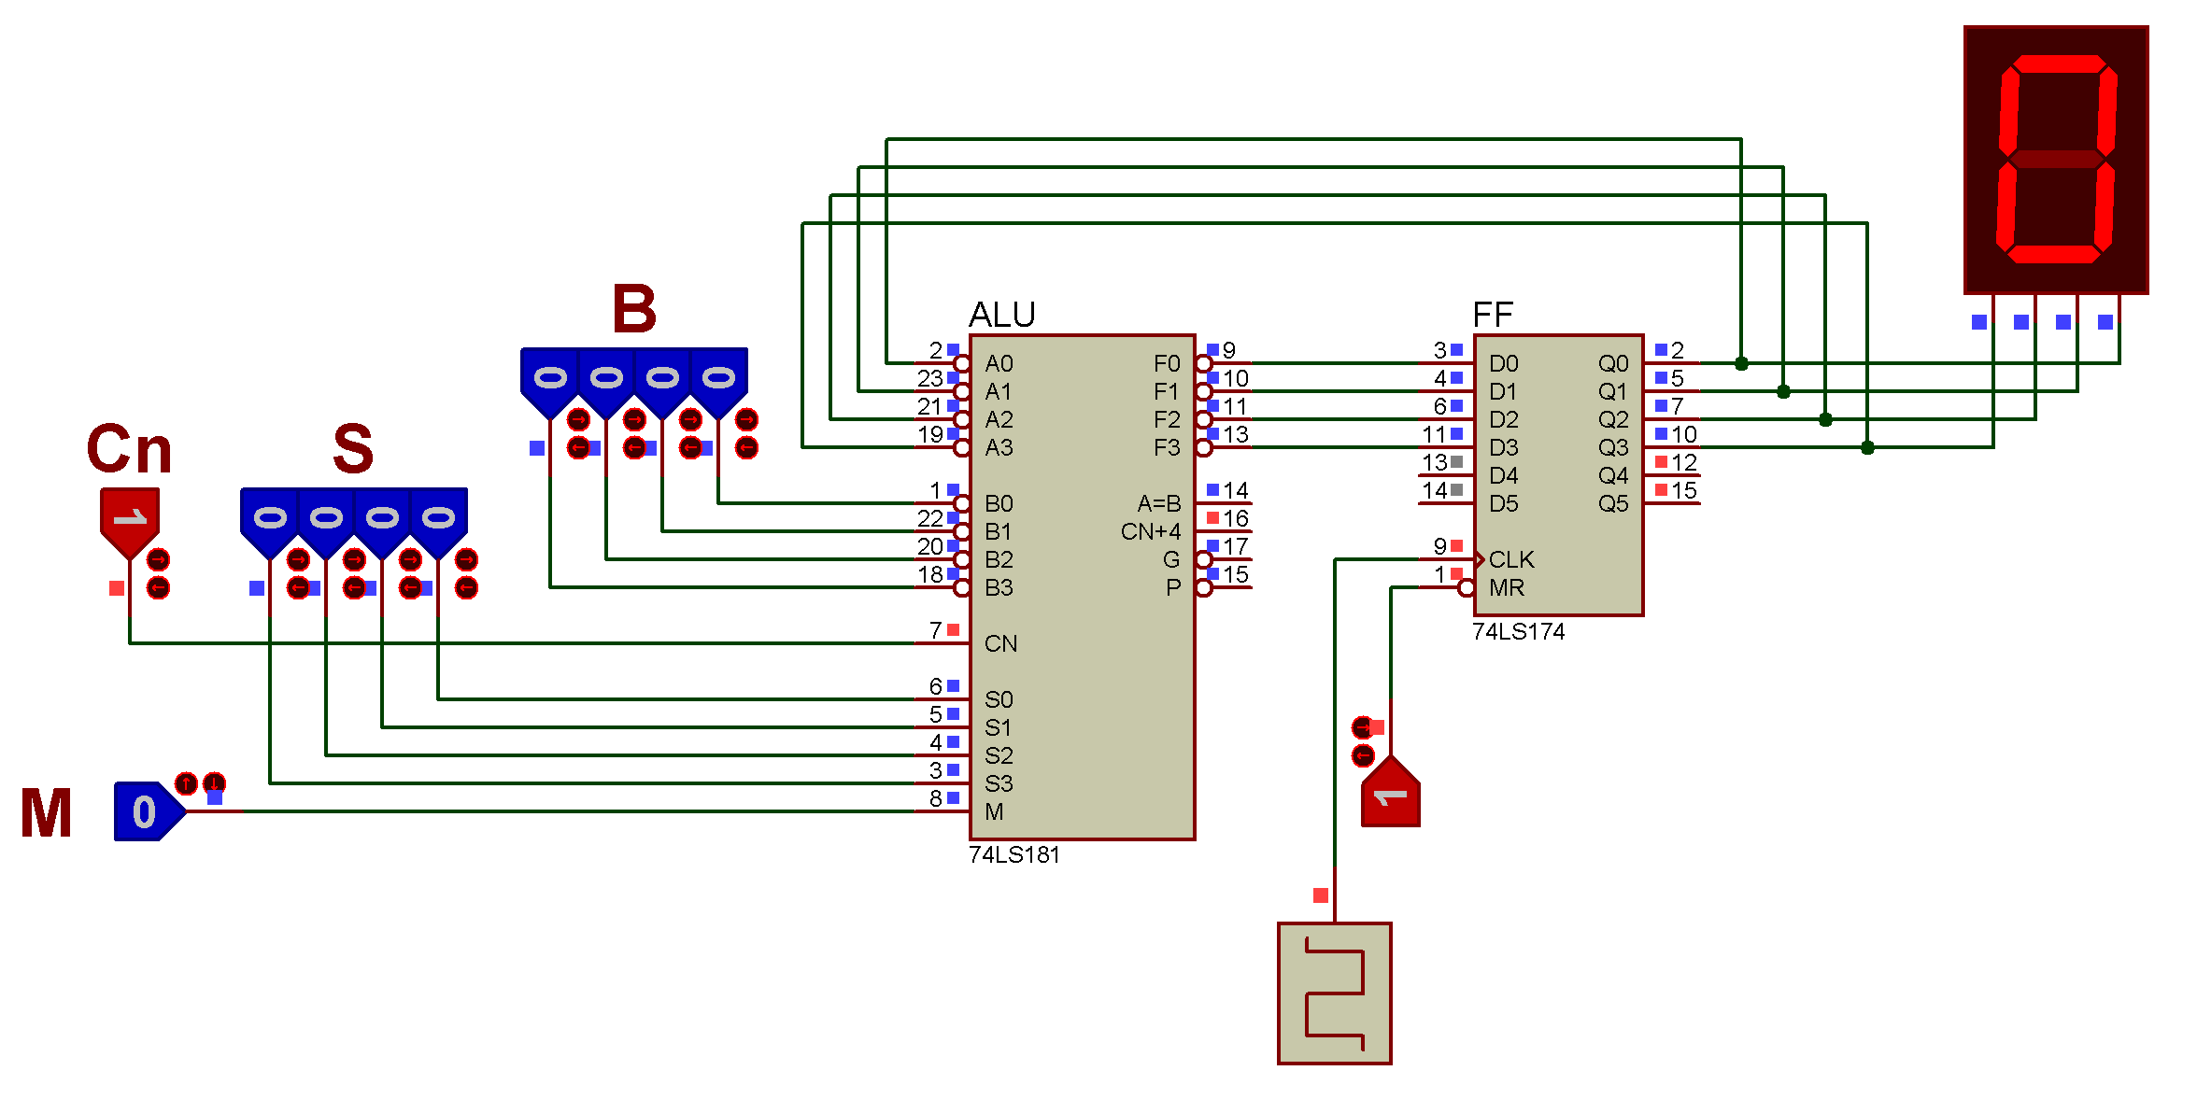
Answer of Question #3

